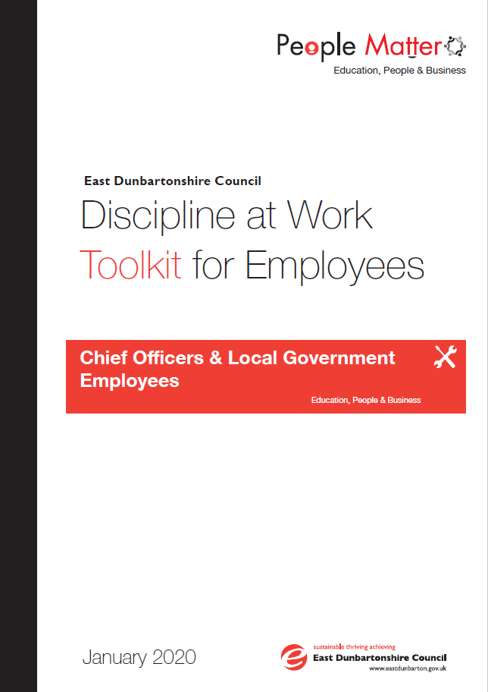

**Contents**

1.0 PURPOSE 3

2.0 SCOPE 3

3.0 UNDERPINNING PRINCIPLES & OBJECTIVES 3

4.0 PROCESS 3

*4.1* *Process Overview* 3

*4.2* *Informal Action* 4

*4.3* *Risk Mitigation & Suspension* 4

*4.4* *Criminal Charges and Convictions* 5

*4.5* *Guidance for Fact Finding* 5

How are Fact Findings conducted? 6

*4.6* *The Fact Finding Report* 6

*4.7*  *Disciplinary Hearing and Appeal Hearing* 6

*4.8*  *Delegated Authority Table* 7

*4.9*  *Disciplinary Outcomes* 7

*4.10* *Appeals* 9

*4.11* *HR Appeals Board* 9

5.0 Contact & Support Details 9

**Appendix 1: Notification of Disciplinary Appeal Form** **10**

Appendix 2 - Guidance Notes for Employees – Preparing for a HR Appeals Board 13

# PURPOSE

This toolkit is to provide assistance to employees who may be subject or involved in the Council’s Discipline at Work Policy and procedures, providing access to information they may require in relation to the process and the relevant paperwork which they may need to complete. This toolkit should be read with the Discipline at Work Policy.

# SCOPE



The Discipline at Work toolkit applies to Local Government Employees, Craft Employees and Chief Officers.

Special procedural requirements, relating to the application of the Discipline at Work Policy for those employees on SNCT Conditions of Service are detailed in the Education Procedure Manual 2/18 – Disciplinary Procedure for Teachers and Toolkit.

The Discipline at Work Policy does not apply to redundancy dismissals or the expiry of fixed term contracts.

# UNDERPINNING PRINCIPLES & OBJECTIVES



To support the Discipline at Work Policy by providing employees with the relevant information and paperwork to support them in the process.

**All Matters** should be dealt with in the following way:

* + If appropriate **Informal approach** considered as the first step in resolving issues
  + Issues raised and dealt with **promptly** without unnecessary delay
  + Management actions are **consistent**
  + **Appropriate fact findings** carried out to establish facts of each case
  + Any disciplinary hearing will be conducted by a **manager not involved** in the matter however issues relating to **performance will involve the immediate line manager**
  + In cases of disciplinary matters, the employee should **understand the basis of the allegation** (which is confirmed in writing) and has the opportunity to present their case before decisions are made
  + The **right to be accompanied** at any discipline at work meeting/hearing ( relevant companions/representatives are outlined in Section 4. Definitions of the Discipline at Work Policy)
  + The **right of appeal** against formal decisions involving the employee.

# PROCESS



### *Process Overview*

The Discipline at Work Policy has the following stages in the process, however depending on the seriousness of the allegation it will not always be appropriate to use informal action in the first instance:

* Informal Action
* Formal Fact Finding
* Disciplinary Hearing
* Disciplinary Appeal Hearing
* HR Appeals Board



### *Informal Action*

Where Informal action is relevant Line managers are encouraged to address issues with the employee at the earliest point possible. The informal approach may involve:

* Talking in private to discuss the concern and understand the root of the problem
* Managers will keep a brief note of informal approaches and agreed remedies

Employees will not be entitled to representation at this stage as it is an informal meeting between employee and manager. In addressing issues raised in an informal way the following may be implemented as mechanisms to provide support:

**Coaching:** Coaching may be appropriate where an employee raises a concern or complaint in relation to the role that they perform. The types of coaching that may be used could involve on the job training, job shadowing. This usually lasts for a short period and focuses on specific skills and goals.

**Mediation:** Mediation may be appropriate as a means of solving or working to improve relationships following disagreement or misunderstandings occurring. The mediator will be objective in the process and can help parties reach agreement where it is otherwise seen to be impossible. Mediation is conducted on the basis that parties involved want to reach a mutually agreeable outcome and solution. This is a voluntary process and will only take place if both parties agree. Mediation is a confidential process where the terms of discussion are not disclosed to any party outside the mediation hearing.

**Training:** Training for employees may be an appropriate outcome to ensuring that the issues raised by an employee are fully or partly addressed where a gap in skills, knowledge or competence to carry out the role have been raised by an employee.

**Informal Stage Improvement Planning:** Improvement planning can form part of informal action where an employee’s conduct or performance has caused concern. Through discussion, the employee will have an awareness of what is expected of them and will be made aware of the consequences if performance does not reach a satisfactory standard in a reasonable timescale.

**The Performance Development Review (PDR) Framework:** Please refer to the procedures established within the PDR Framework & PDR Toolkit for guidance on addressing issues within the course of the PDR Framework communication and the setting, monitoring and review of objectives.

### *Risk Mitigation & Suspension*

Following a serious allegation/incident, it may be necessary for the Manager to put in to place immediate measures to reduce the risks for all parties concerned including the employee. Suspension should **not be viewed as a punishment** and will be on full pay.

The Suspension will initially be for 14 days and regular reviews (fortnightly) will take place as to whether suspension is still required and can be lifted at any point. Suspension may arise in cases of Gross Misconduct but **does not imply guilt or blame** but is a mechanism to prevent further risk until the allegations/incidents is sufficiently investigated or further information is received which informs the risk is no longer present or manageable.

Where suspension is required an employee will be invited to a meeting by a 3rd Tier manager or above and has the right to be accompanied by a Companion/Employee Representative. A HR Case Adviser may also be present.

The employee will be advised of the suspension however the detail of the allegations/incident will not be discussed at this point. The suspension will be confirmed in writing following the meeting. The employee will be provided with the following information:

* + - Reason for suspension – without discussing the detail i.e. an allegation has been made;
    - How long the suspension is initially for;
    - How often this will be reviewed and the communication they will receive in relation to these reviews and/or any extensions or lifting of the suspension;
    - Who their contact officer will be whilst suspended for support, questions and work updates not related to the Fact Finding;
    - That a Fact Finding will take place and the next steps;
    - That they should not enter an EDC place of Business unless requested to do so for meetings;
    - That they should return their laptop, keys, ID badge etc in the interim period;
    - That they are expected to be available for work at any time and the suspension will be reviewed at regular intervals as information is received;
    - If they require any form of leave this should be through the normal leave application process through their contact officer including the informing of sick leave;
    - Details of the Employee Assistance Programme for support

The employee should be informed of any extension to their suspension in writing

### *Criminal Charges and Convictions*

Where an employee has been committed or is convicted of a criminal offence they should inform their Line Manager. An assessment will be carried out as to whether there is any reputational risk to the Council or direct impact on the role the employee undertakes. This assessment can also be referenced should this information be raised again in the future by other parties to evidence it has been disclosed, assessed and there is no impact on the employees employment with the Council.

Only where the criminal charge or conviction has been assessed to have an impact on the role the employee is carrying out will a formal Fact Finding be launched and depending on the circumstances there may be a requirement to consider implementing measures to the role to mitigate risk or suspension.



### *Guidance for Fact Finding*

**What is a Fact Finding?**

A fact finding is a way of establishing the facts of an incident or allegation made in relation to an employee. The fact finding is not a hearing to take disciplinary action. Fact Finding will generally involve meeting with the employee at which point they will be made aware of the allegations and that fact finding will be completed before any disciplinary procedures are considered or take place.

In some cases, the fact finding stage will be the collation of evidence or information for use at a disciplinary hearing.

**Who will conduct a Fact Finding?**

Fact finding Officers will be appointed to establish the facts of the circumstances surrounding an incident or allegation. Fact Finding Officers will be appointed by the relevant Senior Officer in accordance with the delegated authority and will have had no prior involvement in the issue.

The Fact Finding Officer will not make a decision on further action or any outcomes of the process but will merely report on the facts.

In complex cases two Fact Finding Officers may be appointed and will work together.

### How are Fact Findings conducted?

Fact finding are progressed as follows:

* Employees will be invited to a Fact Finding meeting by letter;
* An employee may also receive an invite to a Fact Finding meeting if they have witnessed or have knowledge of an issue. They will be invited as a witness only and any change to this status will be informed in writing;
* For employees who have allegations/concerns raised against them they will be informed of this and any potential for disciplinary action;
* The employee has the right to appropriate representation;
* Employees will have the opportunity to request reasonable adjustments to support their attendance where applicable i.e. employees with disabilities;
* The Fact Finding Officer will ask a series of questions to establish the facts around the issue;
* During the meeting employees are able to request an adjournment/break if they require;
* A note of the Fact Finding meeting will be taken and employee’s will receive a written statement to review and sign for accuracy shortly after the Fact Finding Meeting;
* No recording devices will be allowed in any meeting under this process;
* Statements are not a word for word account of the meeting but should be an accurate reflection of what was discussed;
* The employee for whom the allegations are against will be told that they will receive written notification of the outcome as soon as possible following the meeting. This will be communicated from the appropriate officer considering the report;
* There may be a requirement to attend more than one Fact Finding meeting if further information is required. Employees will also be notified of this in writing;
* Everything discussed at these meetings should remain confidential and not discussed out with the meeting.

### *4.6 The Fact Finding Report*

On concluding the Fact Finding the Fact Finding Officer will review and consider the responses and the information/evidence collated and compile this into a Fact Finding report. This report will be submitted to the relevant officer in line with the delegated authority table for consideration.



### *4.7 Disciplinary Hearing and Appeal Hearing*

Where the decision to progress to a disciplinary hearing has been made on consideration of

the Fact Finding report the employee will receive the following:

* A letter inviting the employee to a hearing giving **no less than** 7 Calendar days’ notice;
* Employees will have the right to appeal decisions within 14 Calendar days of receipt of written confirmation of the hearing outcome using the **Disciplinary Hearing Appeal Form – Appendix 1;**
* Any relevant witness statements, fact finding report and information to be referred to at the hearing will be sent with the letter inviting the employee to a hearing along with a copy of the Discipline at Work Policy;
* The employee will have the opportunity to respond to any witness statements and information that is being considered at a hearing in presenting their case;
* Hearings should be arranged within a reasonable time frame and without unreasonable delay.
* The employee is responsible for arranging any witnesses they wish to call and their representation;
* In exceptions circumstances where timescales may vary employees will be receive communication and kept up to date;
* The Disciplinary Hearing Format (and Appeal Hearing Process) is outlined in section 5.11 of the Discipline at Work Policy;
* Rescheduling of hearings will be accommodated as far as possible but reasons will need to be provided on such requests and these should be within the allocated time within the Policy (refer to Section 5.13)

### *4.8 Delegated Authority Table*

The table below outlines the authorised level of delegation to undertake disciplinary hearings.

|  |  |  |  |  |
| --- | --- | --- | --- | --- |
| **Disciplinary Action** | **Authorised Level of Management to issue Disciplinary Action** | **Consultation with HR Operations Team Essential** | **Authorised Level of Management to hear Appeals against Disciplinary Action** | **HR Appeal Board Appeal Possible** |
| Formal Improvement Plan - Written Warning | 5th Tier Team Leader/Manager or above | Advisable | Next Level Line Manager | No |
| Final Written Warning | 3rd Tier Manager or above | Yes | Next Level Line Manager | No |
| Punitive Action | Depute Chief Executive/Executive Officer | Yes | HR Appeals Board | Yes |
| Dismissal/Summary Dismissal | Depute Chief Executive/Executive Officer | Yes | HR Appeals Board | Yes |

### *4.9 Disciplinary Outcomes*

The employee will receive an outcome to the disciplinary hearing verbally on the day if possible with this confirmed in writing within 7 calendar days. If further time is required to consider the information presented, especially in complex cases the employee will be informed of this at the hearing and receive the outcome in writing within 7 Calendar days. The following outcomes are outlined in section 5.14 of the Discipline at Work Policy and consist of:

* No action/recommendations made
* Formal Written Warning (Formal Improvement Plan – Live for 6 months)
* Final Written Warning (Live for 12 months)
* Dismissal (with and without notice)
* Other Disciplinary Action

**Formal Improvement Plan**

Formal Improvement plans may be used as part of the disciplinary procedure to address concerns relating to conduct and or performance. The employee will be advised of the need for a Formal Improvement Plan in the letter confirming the outcome of the disciplinary hearing. This will form the Written Warning stage of the procedures and will normally remain live for a period of 6 months.

The employee will be issued with a copy/additional copy of the agreed Formal Improvement Plan following the Disciplinary Hearing.

Improvement planning provides a two way communication process for the employee and line manager to work together to address concerns. The line manager will:

* Discuss and complete the ‘Formal Improvement Plan Agreement’ following the Disciplinary Hearing where the facts of the case are clear;
* Discuss where performance/conduct has been considered to be unsatisfactory
* Discuss timescales for improvement and the 6 month deadline for the improvement to be met;
* Note failure to reach the appropriate levels of improvement may lead to further action being taken;
* Any further issues within the 6 month period may lead to further action being taken which could include dismissal;
* Review meetings will be arranged to ensure the employee and line manager have an opportunity to discuss progress prior to the 6 month deadline being met;
* The employee will have the right to be accompanied at the progress review meetings and final review of the improvement plan;
* The employee will be informed when they have met the improvement levels expected;
* Where the improvement has been met the standard expected, the employee will be informed that the Formal Written Warning will be removed from their record.

**Other Disciplinary Action**

Other disciplinary action may be appropriate depending on the circumstances surrounding the individual case. These may include:

* Disciplinary Transfer
* Disciplinary Suspension without pay (up to 5 working days)
* Demotion
* Loss of seniority
* Loss of increment

Any decisions made under the Discipline at Work policy will consider the reasonableness of the decision relating to the circumstances of the issue.

### *4.10 Appeals*

Employees have the right to appeal the decision of the disciplinary hearing within 14 workings days of receipt of written confirmation of the hearing outcome using the **Disciplinary Hearing Appeal Form – Appendix 1.**

The Appeals Hearing format is the same as for Disciplinary Hearings as is outlined in section 5.11 of the Discipline at Work Policy. All Appeals will be considered by a manager and/or Executive Officer who is impartial and has not been involved in the case at any stage.

Notification and requirements of the Appeal Hearing will be the same as for the Disciplinary Hearing.

### *4.11 HR Appeals Board*

Appeals against dismissal will be heard by the HR Appeals Board. The process for the HR Appeals Board is outlined in **Appendix 2 of the Discipline at Work Policy** however **Guidance Notes for Employees** in preparing for a HR Appeals Board can be found in **Appendix 2** of this toolkit.

# Contact & Support Details

Queries in relation to the Discipline at Work Policy and Employee Toolkit can be directed to your Line Manager and/or advice and support is available from your Trade Union Representative.

Further information can also be sought from your HR Case Adviser at:

|  |  |  |  |
| --- | --- | --- | --- |
| **HR Case Advisers** | | | |
| **Name** | **Job Title** | **Email** | **Ext No** |
| Anne Marie Cunningham | Team Leader HR Operations | [annemarie**_**cunningham@eastdunbarton.gov.uk](mailto:annemarie_cunningham@eastdunbarton.gov.uk) | 5535 |
| Nikki Edgar | HR Case Adviser | [nikki.edgar@eastdunbarton.gov.uk](mailto:nikki.edgar@eastdunbarton.gov.uk) | 5647 |
| Lorna McLaughlin | HR Case Adviser | [lorna.mclaughlin@eastdunbarton.gov.uk](mailto:lorna.mclaughlin@eastdunbarton.gov.uk) | 3243 |
| Susie Andrews | HR Case Adviser | [susie.andrews@eastdunbarton.gov.uk](mailto:susie.andrews@eastdunbarton.gov.uk) | 5608 |
| Susan Hamilton | HR Case Adviser | [susan.hamilton@eastdunbarton.gov.uk](mailto:susan.hamilton@eastdunbarton.gov.uk) | 5628 |

Contact details can also be found on the Hub at: [Workforce Strategy Contact List](http://thehub.eastdunbarton.gov.uk/sites/default/files/documents/council/plans-policies-and-strategies/workforce_strategy_contact_list.pdf)

Support is also available from the Council Employee Assistance Programme Time for Talking:

Telephone: 0800 9703980

Email: [admin@timefortalking.co.uk](mailto:admin@timefortalking.co.uk)

Website: [www.timefortalking.co.uk](http://www.timefortalking.co.uk)

Online Chat Password: TfTnow

# Appendix 1: Notification of Disciplinary Appeal Form

|  |  |
| --- | --- |
| **Personal Details** | |
| Name: | Employee  Reference: |
| Designation: | Department: |
| Location: | Contact Number: |
| Any correspondence related to the discipline should be forwarded to the address below:  It is the responsibility of the employee to provide a work/home address for all correspondence | |

|  |  |
| --- | --- |
| **Companion Details** | |
| Trade Union Name: | Trade Union Rep: |
| Other Representative: | |

|  |  |
| --- | --- |
| **Disciplinary Action Taken** | |
|  | |
| **Appeal Hearing** | |
| First Appeal |  |
| Appeal to HR Appeals Board  ***(not applicable to Written/Final Written Warning)*** |  |
| **Grounds of Appeal** | |
| The action taken is unfair in the circumstances |  |
| The level of disciplinary action taken |  |

|  |
| --- |
| **Grounds of Appeal**  **Please state the ground of your appeal in the space provided** |
|  |
| **Proposed Remedy to the issue** |
|  |

|  |  |  |
| --- | --- | --- |
| **Ground of Appeal – Optional Guide** | | |
| Do you admit or deny the offence for which disciplinary action was taken against you? | Admit | Deny |
| **If you admit the offence, but wish to submit an explanation of your conduct or provide a statement of mitigation, please do so.** | | |
|  | | |
| **If you deny the offence, please give your account of the incident** | | |
|  | | |
| **If you wish to submit additional evidence, not considered as part of the disciplinary hearing, please do so with clarification of why this was not previously raised** | | |
|  | | |
| **If you dispute the reasons for disciplinary action please state what, in your opinion was the reason for action taken against you.** | | |
|  | | |
| **If you consider the action taken against you excessive, please state why.** | | |
|  | | |

|  |
| --- |
| **Employee** |
| Signature: |
| Date: |

|  |  |
| --- | --- |
| **Written /Final Written Warnings/Punitive Action** | **Dismissal** |
| **Complete and send to:**  Executive Officer of Strategic Area | **Complete and send to:**  Depute Chief Executive - Education, People and Business  East Dunbartonshire Council  Southbank Marina   |  | | --- | | 12 Strathkelvin Place Kirkintilloch | |  | |  |  | |  |  | |  |  |   Glasgow  G66 1TJ |

## Appendix 2 - Guidance Notes for Employees – Preparing for a HR Appeals Board

On receipt of your Notification of Disciplinary Appeal Form initiating an appeal to the HR Appeals Board, arrangements will be made to schedule the case for an HR Appeals Board in line with the pre-determined timetable. You will be notified in writing advising of the date of the HR Appeals Board.

In the meantime, you (the appellant) should as a priority:-

**Consider Representation and Witness(es):**

You have a right to be accompanied by a trade union representative, or colleague at the hearing, even if you have chosen not to be accompanied at earlier stages of the case.

If you do wish to be accompanied, you must consider whether you wish to present your own case or whether you would prefer your representative to do so on your behalf. Whatever your preference, you should contact and discuss the appeal with your representative as soon as possible and certainly prior to the hearing.

Whether you wish to call any witnesses (who must be available, even if you choose not to call them in to the main hearing on the day).

It is your responsibility to ensure all documents that you wish the Board to consider are forwarded to the Assistant to the Depute Chief Executive – Education, People and Business. These might include:

* Letters from previous stages
* Any other relevant correspondence including emails
* Records
* Minutes
* You may wish to submit an optional written statement to the HR Appeals Board which highlights/summarises the points which you wish to be considered.

Please ensure that any copies of documents submitted are:

* Single-sided,
* Legible - where appropriate, hand-written documents should be reproduced in type print.
* Without staples

**Please note it is your responsibility to ensure that your representative and any witnesses you may wish to call are aware of the arrangements for the hearing.**

Your full submission must be with the Assistant to the Depute Chief Executive - Education, People and Business at **least** 10 working days before the date of the Hearing.

Your submission will be collated along with the management submission. Committee Administration will circulate copies to the Board and the Assistant to the Depute Chief Executive - Education, People and Business will distribute copies to you, your representative and the management team at least 5 days before the hearing.

The Human Resources Appeals Board comprises eight elected members; a minimum of three must hear the appeal. The Chief Solicitor and Monitoring Officer (or nominated officer) and the Executive Officer Organisational Transformation (or nominated officer) will also be on the panel to act as advisers to the Board.

**Other Formats & Translations**

This document can be provided in large print, Braille or on audio cassette and can be translated into other community languages. Please contact the Council’s Corporate Communications Team at:

East Dunbartonshire Council, 12 Strathkelvin Place, Southbank

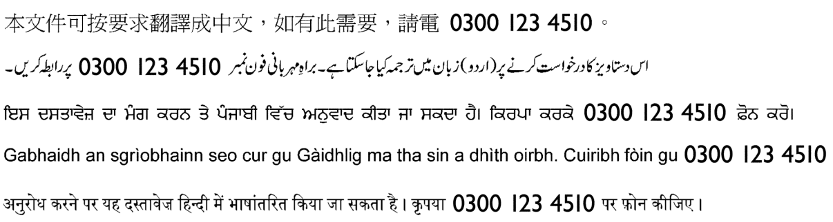**Kirkintilloch G66 1TJ Tel: 0300 123 4510**