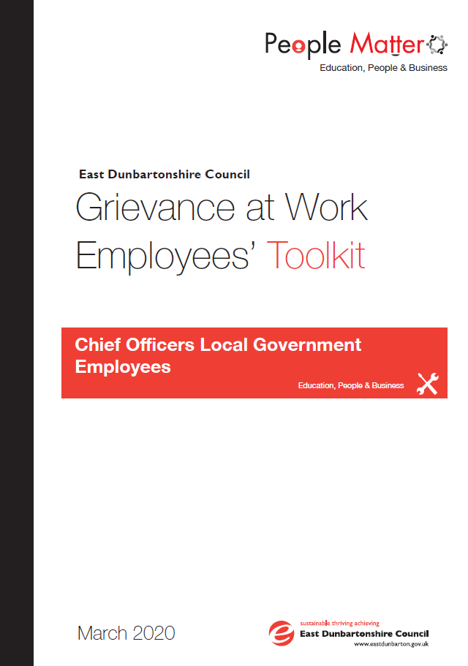

**Contents**

1.0 PURPOSE 3

2.0 SCOPE 3

3.0 UNDERPINNING PRINCIPLES & OBJECTIVES 3

4.0 PROCESS 3

4.1 Process Overview 3

4.2 Informal Action 3

4.3 Grievance at Work Procedures 4

4.3.1 Grievance Hearing 5

4.3.2 Guidance for Fact Finding 5

4.4 Appeals 6

4.5 Opportunity for Appeal 6

5.0 Contact & Support Details 7

Appendix 1: Notification of Grievance Form 8

Appendix 2: Notification of Grievance Appeal 9

# PURPOSE

This toolkit is to provide assistance to employees who may be subject or involved in the Council’s Grievance at Work Policy and procedures, providing access to information they may require in relation to the process and the relevant paperwork which they may need to complete. This toolkit should be read with the Grievance at Work Policy.

# SCOPE



The Grievance at Work toolkit applies to Local Government Employees and Chief Officers. Teaching employees should refer to the procedures outlined in the SNCT Handbook of Conditions of Service.

# UNDERPINNING PRINCIPLES & OBJECTIVES



To support the Grievance at Work Policy by providing employees with the relevant information and paperwork to support them in the process.

All matter should be dealt with in the following way:

**All Matters** should be dealt with in the following way:

* + If appropriate **Informal approach** considered as the first step in resolving issues
  + Issues raised and dealt with **promptly** without unnecessary delay
  + Management actions are **consistent**
  + **Appropriate fact findings** carried out to establish facts of each case
  + Any grievance hearing will be conducted by a **manager not involved** in the matter giving rise to dispute
  + Employees have the **right to be accompanied** at any grievance at work hearing (relevant companions/representatives are outlined in Section 4. Definitions of the Grievance at Work Policy.
  + Employees have the **right of appeal** against formal decisions made in matters which involve them.

# PROCESS



### *Process Overview*

The Grievance at Work Policy has the following stages in the process, however depending on the nature of the grievance it may not always be appropriate to use informal action in the first instance.

* Informal Action
* Grievance Hearing
* Fact Finding
* Grievance Appeals



### *Informal Action*

In some instances, the informal stage of procedures may not be appropriate due to the nature of the complaint. Where the grievance relates directly to their line manager the employee can request advice from the HR Adviser.

Where Informal action is relevant Line managers are encouraged to address issues with the employee at the earliest point possible. The informal approach may involve:

* Talking in private to discuss the concern and understand the root of the problem
* Managers will keep a brief note of informal approaches and agreed remedies

Employees will not be entitled to representation at this stage as it is an informal meeting between employee and manager. In addressing issues raised in an informal way the following may be implemented as mechanisms to provide support:

**Coaching:** Coaching may be appropriate where an employee raises a concern or complaint in relation to the role that they perform. The types of coaching that may be used could involve on the job training, job shadowing. This usually lasts for a short period and focuses on specific skills and goals.

**Mediation:** Mediation may be appropriate as a means of solving or working to improve relationships following disagreement or misunderstandings occurring. The mediator will be objective in the process and can help parties reach agreement where it is otherwise seen to be impossible. Mediation is conducted on the basis that parties involved want to reach a mutually agreeable outcome and solution. This is a voluntary process and will only take place if both parties agree. Mediation is a confidential process where the terms of discussion are not disclosed to any party outside the mediation hearing.

**Training:** Training for employees may be an appropriate outcome to ensuring that the issues raised by an employee are fully or partly addressed where a gap in skills, knowledge or competence to carry out the role have been raised by an employee.

**The Performance Development Review (PDR) Framework:** Please refer to the procedures established within the PDR Framework & PDR Toolkit for guidance on addressing issues within the course of the PDR Framework communication and the setting, monitoring and review of objectives.



### *Grievance at Work Procedures*

Grievances should be raised informally in the first instance where the circumstances allow for this approach. This can be done through an employee requesting a meeting with the line manager or the line manager taking action where an issues is apparent.

In some instances, the informal stage of procedures may not be appropriate due to the nature of the complaint. Where the grievance relates directly to the line manager the employee can request advice from the HR Adviser.

Formal Grievances should be raised using the Notification of Grievance Form – form can be found in Appendix 1. Where there is a joint grievance involving a number of employees the appointed manager to hear the grievance will request that nominated employees from the group attend to present the grievance on behalf of the group along with their representative/s. However all employees who are part of the grievance can expect to have the outcome and any other relevant information communicated to them throughout the process.

Employees should be aware that all records of meetings, completed forms and any other correspondence in relation to any matters can be used throughout the Grievance at Work process and may be considered on any appeals stages.

### Grievance Hearing

Where a formal grievance has been raised a grievance hearing will be arranged. The employee will receive the following:

* A letter inviting them to the hearing giving no less than 7 calendar days’ notice (any relevant witness statements will be included)
* The employee will be informed of the outcome of the grievance in writing without unreasonable delay
* In exceptional circumstances, these timescales may vary however, ongoing communication will be made with the employees to keep them up to date.

The hearing will allow the employee to present their case, provide any supporting evidence relating to the grievance and propose the way they see the issue being resolved. A written record will be taken of the hearing.

In certain cases there may be a need for a grievance hearing to be postponed to establish the facts of the issue. In such circumstances, the employee will be communicated with.

All employees will have the right to be accompanied at the hearing.

It may be appropriate to take an adjournment to allow any mitigating factors or further information required to be addressed.

Managers may not be able to provide an outcome to the grievance following the hearing and may have to adjourn the hearing if there is a requirement to establish the facts of the issue and/or seek further information. In certain circumstances this may involve the undertaking of a fact finding.

### Guidance for Fact Finding

**What is a Fact Finding?**

A fact finding is a way of establishing the facts of an incident or allegation made in relation to an employee. The fact finding is not a hearing but will generally involve meeting with relevant employee/s at which point they will be made aware of the allegations/reasons for the fact finding. The Fact Finding may involve the instigation of Discipline at Work Policy depending of the facts established.

**Who will conduct a Fact Finding?**

The Manager appointed to hearing the grievance will undertake the fact finding to establish the facts of the circumstances surrounding an incident or allegation. However depending on the circumstances a different Manager may be appointed.

**The Fact Finding Report**

On concluding the Fact Finding the manager will review and consider the responses and the information/evidence collated and compile this into a Fact Finding report which will inform the Grievance outcome. The possible outcomes of the Grievance are:

* Uphold the grievance – to Support the employees case if full;
* Uphold the grievance in part – support certain points of the employees case;
* Not to uphold the grievance – The employee’s case is not supported in full.

### *Appeals*

Where the employee does not agree with the outcome of the grievance hearing there is a right to appeal in line with section 5.3.6 of the Grievance at Work Policy. There are 2 appeal stages.

Appeals to the grievance hearing decision must be submitted within 14 calendar days of the response of the initial hearing or stage 1 appeal hearing using the Grievance Appeal Form (appendix 3)

The employee will receive a letter inviting them to the appeal hearing without unreasonable delay.

The outcome of the appeal will be confirmed in writing within 7 calendar days of the hearing. The format of the appeal hearing is outlined in Appendix 1



### *Opportunity for Appeal*

|  |  |
| --- | --- |
| **Grievance Action** | **Authorised Level of Management to hear Appeals against Grievance Decision** |
| Formal Grievance Hearing | 3rd Tier Manager or 4th Tier Team Leader |
| Appeal Hearing (Appeal 1) | Next Tier Manager |
| Appeal Hearing (Appeal 2) | Executive Officer |

**For Grievances raised against Executive Officers and Depute/Chief Executives**

|  |  |
| --- | --- |
| **Grievance Action** | **Authorised Level of Management to hear Appeals against Grievance Decision** |
| Formal Grievance Hearing | Executive Officer, Depute Chief Executive or Chief Executive |
| Appeal Hearing (Appeal 1) | Depute Chief Executive, Chief Executive or HR Appeals Board** |
| Appeal Hearing (Appeal 2) | Chief Executive or HR Appeals Board if not previously heard |

**For Executive Officers and Depute/Chief Executives**

|  |  |
| --- | --- |
| **Grievance Action** | **Authorised Level of Management to hear Appeals against Grievance Decision** |
| Formal Grievance Hearing | Depute Chief Executive or Chief Executive |
| Appeal Hearing (Appeal 1) | Chief Executive or Appeals Sub Committee ** |
| Appeal Hearing (Appeal 2) | HR Appeals Board if not previously heard |

** An HR Appeals Board Committee will be made up of appropriate Elected Members.

Only where a grievance is in relation to an Executive Officer or Depute/Chief Executive will a HR Appeals Board be implemented.

In exceptional circumstances, these timescales may vary however, ongoing communication must be made with the employee to ensure that they are kept up to date and aware of the reason for variation.

In the interest of consistency, the employee will always present the case first outlining their grounds of appeal followed by management. The format that is outlined below:

* The chair of the appeal hearing will outline the procedure and the purpose of the hearing
* The employee or representative shall be asked to put their case first; calling any witnesses if and when appropriate
* The management side and the chair shall then have the opportunity to ask questions of the employee, their representative and/or any witness(es) called on the employees behalf
* The management side shall then have the opportunity to put forward their case and call any witnesses
* The employee or the employee representative and the chair of the appeal hearing shall have the opportunity to ask questions of the management side and any of their witnesses
* The management side followed by the employee shall have the opportunity to sum up their individual cases.

# Contact & Support Details

Queries in relation to the Grievance at Work Policy and Employee Toolkit can be directed to your Line Manager and/or advice and support is available from your Trade Union Representative.

Further information can also be sought from your HR Adviser at:

|  |  |  |  |
| --- | --- | --- | --- |
| **HR Advisers** | | | |
| **Name** | **Job Title** | **Email** | **Ext No** |
| Nikki Edgar | HR Adviser | [nikki.edgar@eastdunbarton.gov.uk](mailto:nikki.edgar@eastdunbarton.gov.uk) | 5647 |
| Lorna McLaughlin | HR Adviser | [lorna.mclaughlin@eastdunbarton.gov.uk](mailto:lorna.mclaughlin@eastdunbarton.gov.uk) | 3243 |
| Susie Andrews | HR Adviser | [susie.andrews@eastdunbarton.gov.uk](mailto:susie.andrews@eastdunbarton.gov.uk) | 5608 |
| Susan Hamilton | HR Adviser | [susan.hamilton@eastdunbarton.gov.uk](mailto:susan.hamilton@eastdunbarton.gov.uk) | 5628 |
| Natalie Moyes | HR Adviser | [natalie.moyes@eastdunbarton.gov.uk](mailto:natalie.moyes@eastdunbarton.gov.uk) | 3172 |
| Anne Marie Cunningham | Team Leader HR Operations | [annemarie**_**cunningham@eastdunbarton.gov.uk](mailto:annemarie_cunningham@eastdunbarton.gov.uk) | 5535 |

Support is also available from the Council Employee Assistance Programme Time for Talking:

Telephone: 0800 9703980

Email: [admin@timefortalking.co.uk](mailto:admin@timefortalking.co.uk)

Website: [www.timefortalking.co.uk](http://www.timefortalking.co.uk)

Online Chat Password: TfTnow

Support is also available from your Trade Union Representative.

### *Appendix 1: Notification of Grievance Form*

The form should be completed by the employee and submitted following the procedure outlined in the Grievance at Work Policy. Employees can contact a HR Adviser for assistance in completing the form. The form is available in alternative format where required by contacting the HR Adviser.

|  |  |
| --- | --- |
| **Personal Details** | |
| Name: | Employee  Reference: |
| Designation: | Department: |
| Location: | Contact Number: |
| Any correspondence related to the grievance should be forwarded to the address below:  Please outline a work/home address. | |
| **Companion Details** | |
| Trade Union Name: | Trade Union Rep: |
| Other Representative: | |
| **Informal Resolution & Proposed Informal Remedy** | |
| Informal approach taken | |
| Actions/Remedy Proposed | |
| Reason for moving to formal written grievance | |
| **Details of Complaint** | |
|  | |
| **Proposed Remedy** | |
|  | |
| **Employee Signature** | **Date** |
|  |  |

### *Appendix 2: Notification of Grievance Appeal*

The form should be completed by the employee and submitted where an employee is unhappy with the outcome of the grievance hearing. Employees can contact the Employee Relations Team for assistance in completing the form. The form is available in alternative format where required by contacting the Employee Relations Team.

|  |  |
| --- | --- |
| **Stage of Appeal** | |
| Appeal against Grievance Hearing Decision (Appeal 1) |  |
| Appeal against Appeal Hearing Decision (Appeal 2) |  |

|  |  |
| --- | --- |
| **Personal Details** | |
| Name: | Employee  Reference: |
| Designation: | Department: |
| Location: | Contact Number: |
| Any correspondence related to the grievance should be forwarded to the address below:  Please outline a work/home address. | |

|  |  |
| --- | --- |
| **Companion Details** | |
| Trade Union Name: | Trade Union Rep: |
| Other Representative: | |

|  |  |
| --- | --- |
| **Details of Previous Hearing** | |
| Date Held: | Grievance heard by: |
| Grievance Outcome Letter Received: | |

|  |
| --- |
| **Nature of Original Grievance** |
|  |
| **Proposed Remedy at Grievance Hearing by Manager** |
|  |
| **Reason for Appeal** |
|  |
| **Proposed Remedy by Employee at Appeal Stage** |
|  |

|  |  |
| --- | --- |
| **Employee Information** | |
| Signature |  |
| Date |  |

**Other Formats & Translations**

This document can be provided in large print, Braille or on audio cassette and can be translated into other community languages. Please contact the Council’s Corporate Communications Team at:

East Dunbartonshire Council, 12 Strathkelvin Place, Southbank

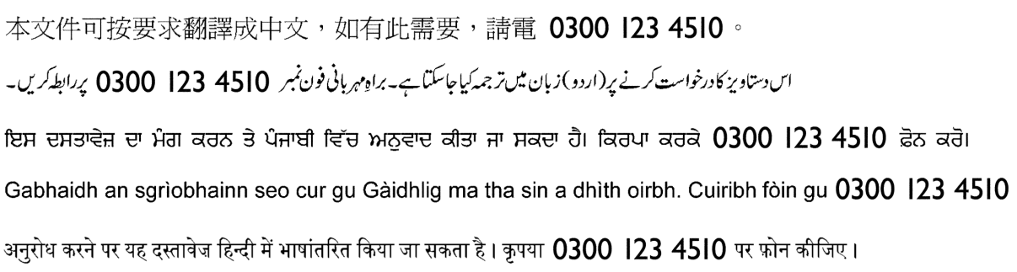**Kirkintilloch G66 1TJ Tel: 0300 123 4510**