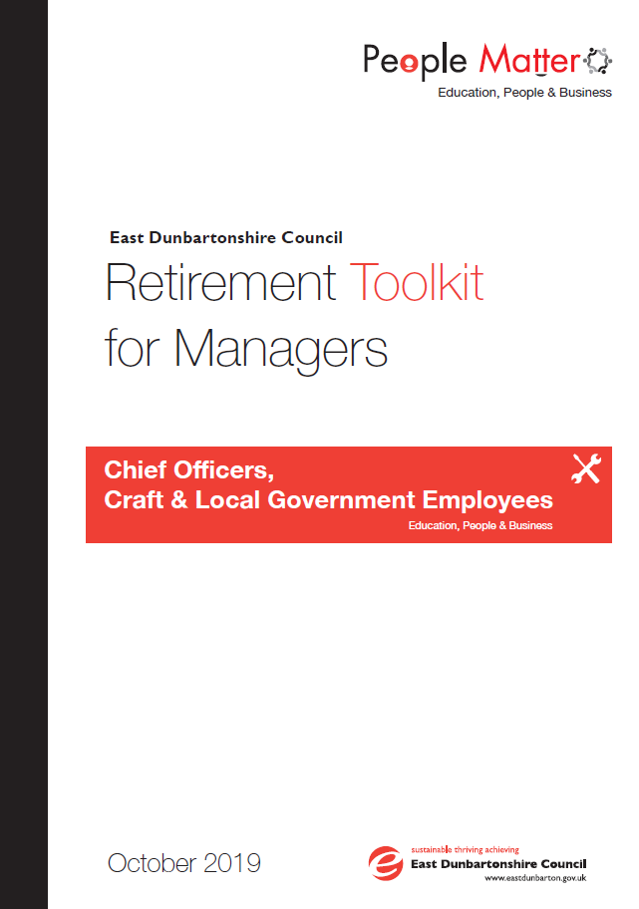

**Contents**

1.0 OVERVIEW 3

2.0 AIMS & OBJECTIVES 3

3.0 REFERENCES AND RELATED DOCUMENTS 3

4.0 RETIREMENT OPTIONS 3

4.1 Flexible Retirement 3

4.2 Age Retiral 5

4.2.1 Pre-Retirement Leave 5

4.2.2 Planning for a Positive Retirement 5

Appendix A: Age Retirement Flow Chart 6

Appendix B: Flexible Retirement Flow Chart 7

Appendix C: Application for Flexible Retirement 8

Appendix D: Template Letters 11

Appendix E: Rule of 85 12

# **1.0 OVERVIEW**

* 1. The toolkit is designed to assist managers in implementing the Council’s Retirement Policy consistently and effectively and ensuring that employees are aware of the options available for full and flexible retirement.

Employees who are members of the LGPS are required to give a minimum of **6 months’** notice to ensure that retirement arrangements are in place at their date of retirement.

# **2.0 AIMS & OBJECTIVES**

2.1 The primary aims of this toolkit is to provide Managers with a structured guide to support employees to prepare for retirement. This took-kit aims to:

* Outline the framework for dealing with retirement issues and the relevant steps that a line manager/employee should undertake in line with the Council’s Retirement Policy.
* Provide comprehensive guidance on the process of dealing with queries in relation to the Council’s Retirement Policy.
* Implement a framework that provides standard formats for implementing practices which take account all aspects of the Council’s Retirement Policy.

# **3.0 REFERENCES AND RELATED DOCUMENTS**

3.1 References and related document to this toolkit include:

* [**Retirement Policy**](http://thehub.eastdunbarton.gov.uk/council/plans-policies-and-strategies/retirement-policy)
* [**Flexible Working Policy**](http://thehub.eastdunbarton.gov.uk/flexible-working-policy)

# **4.0** **RETIREMENT OPTIONS**

## 4.1 Flexible Retirement

To apply for Flexible Retirement the employee should in the first instance request figures through their HR Case Management Adviser. Flexible retirement requests that result in a strain on the fund will not be granted. Consideration will only be given to the cases where there are no costs to the Council.

Where an employee wishes to proceed with their application following receipt of their figures they should then complete a Flexible Retirement Application Form and submit this to their Line Manager for approval. The employee must confirm whether they intend to retire on a flexible basis on the following grounds:

(i) Reduction in hours of work, either in their current or alternative role;

**OR**

(ii) Apply for an alternative position within the council, which is of a lower grade than their current substantive role. A minimum reduction of at least one full salary grade will normally be necessary before flexible retirement would be considered. For example, Grade 5 moving to a Grade 4. This will result in a new contract of employment being issued to the employee and they would then move to the terms and conditions and rate of pay for the lower graded post.

When considering an application for flexible retirement the Line Manager must be satisfied that there will be no significant detriment to the service. Where a request can be supported by the Line Manager, the Line Manager should forward the application to their HR Case Adviser prior to forwarding to the Executive Officer for approval. Following final approval of the application, the Line Manager should confirm the decision in writing to the employee using the template letter attached at Appendix D.

The HR Case Management Adviser will then arrange to meet with the employee to complete the relevant paperwork for SPFO.

Where an application for flexible retirement cannot be supported, the Line Manager must states the reason/s for their decision on the application form stating the reason/s for the decision. Grounds for refusal may include:

* the burden of additional costs.
* an inability to reorganise work amongst existing staff.
* an inability to recruit additional staff.
* a detrimental impact on quality.
* a detrimental impact on performance.
* insufficient work for the periods the employee proposes to work.

The Line Manager should then forward the application to their HR Adviser prior to forwarding the application to the Executive Officer.

Following final approval of the application, the Line Manager should confirm the decision in writing to the employee using the template letters attached at Appendix D.

If you are not a member of the Local Government Pension Scheme but you would like to reduce your working hours, you can make an application to do so by using the Flexible Working Policy.

**Rights of Appeal**

If a request for Flexible Retirement is declined, the employee will have the right to appeal the decision should they feel that the decision is unfair. The appeal should be made in writing within 14 days of receipt of the outcome letter to the HR & OD Manager.

The decision of the HR & OD Manager will be final and there will be no further right of appeal.

## 4.2 Age Retiral

The decision to retire should be put in writing by the employee to their line manager. The line manager will then write to the employee acknowledging their decision and will arrange a meeting with them to discuss the retirement arrangements and forward a copy of the letter to the relevant HR Case Management Adviser.

The issues covered at the meeting with the Line Manager can include date of retirement, status of tasks/projects, handover plans and knowledge transfer to colleagues, pre-retirement course, pre-retirement leave, where the employee can access pension details and the return of any Council property. The range of topics covered will vary depending on their relevance to the individual employee and on them meeting qualifying conditions.

The HR Case Management Adviser will arrange to provide the employee with an estimate of the benefits and arrange for the relevant paperwork to be completed and forwarded to SPFO within 3 months of date of retiral.

## 4.2.1 Pre-Retirement Leave

Employees must have at least five years’ continuous service with the Council at the date of retiral to be entitled to pre-retirement leave.

Employees should receive 12 days’ pre-retirement leave over a 12 week period. Should a public holiday occur in the same week, then the leave should be taken in addition to the public holiday.

The above reduction will be applied on a proportionate basis for those employees who work non-standard working patterns (e.g. part-time or shift workers, etc).

The timing of the pre-retirement leave should be agreed in discussion with the employee and the line manager concerned and the Line Manager should record the pre-retirement leave on Itrent as a permissible absence.

Pre-retirement leave which is not taken by the employee at the locally agreed times will be lost (i.e. pre-retirement leave cannot be banked, granted retrospectively or given as payment in lieu). In addition, sickness absence coinciding with pre-retirement leave will be treated as sickness absence and no substitute pre-retirement leave will apply.

## 4.2.2 Planning for a Positive Retirement

Employees are encouraged to attend the half day planning and positive retirement course. Employees will be granted paid leave to attend this training. Further information in this course is available from your HR Case Adviser.

# **Appendix A: Age Retirement Flow Chart**



# **Appendix B: Flexible Retirement Flow Chart**



# **Appendix C: Application for Flexible Retirement**

East Dunbartonshire Council processes personal data in accordance with the General Data Protection Regulations (EU 2016/679), the Data Protection Act 2018 and all other relevant national data protection laws.

Your personal data will be processed in accordance with the council’s privacy notice for employees which is available at: https://www.eastdunbarton.gov.uk/council/privacy-notices.

This application should be submitted to your Line Manager for approval at least **6 months** prior to your anticipated commencement date of your Flexible Retirement.

|  |  |  |  |  |  |  |  |  |  |  |  |  |  |  |
| --- | --- | --- | --- | --- | --- | --- | --- | --- | --- | --- | --- | --- | --- | --- |
| **Section A: EMPLOYEE DETAILS** (please PRINT) | | | | | | | | | | | | | | |
|  | | | | | | | | | | | | | | |
| Name: |  | | | Date of Birth: | | | | |  | | |  | | |
|  | | | | | | | | | | | | | | |
| Employee No: |  | | | NI No: | | |  | | | | |  | | |
|  | | | | | | | | | | | | | | |
| Designation: |  | | | | | | | | | | |  | | |
|  | | | | | | | | | | | | | | |
| **Section B: ELIGIBILITY AND CONDITIONS OF APPLICATION** | | | | | | | | | | | | | | | |
| I wish to apply for flexible retirement in accordance with Regulation 18 of the Local Government Pension Scheme (Scotland) Amendment (No 2) Regulations 2006. The conditions relating to my application are confirmed below: (Please ✓ to confirm or provide details where appropriate) | | | | | | | | | | | | | | | |
| * I am 55 years of age or over | | | | | | | | | | |  | |  | | |
|  | | | | | | | | | | | | | | | |
| * I have 2 or more years of pension scheme membership | | | | | | | | | | |  | |  | | |
| * I understand that I require to reduce my hours of work by a minimum of 20% or reduce my grade | | | | | | | | | | |  | | | | |
|  | |  | | |
| * I understand that flexible retirement involves early payment of my pension benefits which may be subject to actuarial reduction and that this will constitute a permanent contractual change until my final retirement date | | | | | | | | | | |  | | | | |
|  | |  | | |
| Section C: APPLICATION DETAILS: | | | | | | | | | | | | | | | | |
| OPTION 1 | | | | | | | | | | | | | | | | |
| I wish to apply for flexible retirement on the basis of reducing my hours of work by a minimum of 20%. | | | | | | | | | | |  | | | | | |
|  | | |  | | |
| My current weekly hours of work are: | | |  | | hours | | |  | | mins | | | |  | | |
| I request to reduce my weekly hours of work to: | | |  | | hours | | |  | | mins | | | |  | | |
| Outline your preferred working pattern: | | | | | | | | | | | | | | | | |
| OPTION 2 | | | | | | | | | | | | | | | | |
| * I wish to apply for flexible retirement on the basis of reducing my salary grade and maintaining my current working hours. | | | | | | | | | | |  | | | | | |
|  | | |  | | |
| COMMENCEMENT | | | | | | | | | | | | | | | | |
| * Proposed effective date: | | Date: | | | |  | | | | | | | |  | | |
| Please state the impact this will have on your duties: | | | | | | | | | | | | | | | | |
|  | | | | | | | | | | | | | | | | |
|  | | | | | | | | | | | | | | | | |
|  | | | | | | | | | | | | | | | | |
|  | | | | | | | | | | | | | | | | |
|  | | | | | | | | | | | | | | | | |
|  | | | | | | | | | | | | | | | | |
|  | | | | | | | | | | | | | | | | |
|  | | | | | | | | | | | | | | | | |
| **Employee signature: ………………………………… Date application submitted: ………………** | | | | | | | | | | | | | | | | |
| **Section D: Flexible Retirement application details – to be completed by the Line Manager** | | | | | | | | | | | | | | | | | | |

|  |
| --- |
| Please confirm the effect this request will have on your service and how the request will be supported.  . |
| **I have/have not** (delete as appropriate) recommendedapproval of this request for flexible retirement. |
| If the recommendation for flexible retirement is approved, what is the proposed commencement date:  **Date: ……………………** |
| If you have not recommended approval of the request for flexible retirement, please state below the reason/s for your decision: |

|  |
| --- |
| **Section E: Flexible Retirement application details – to be completed by the HR Case Adviser** |

|  |
| --- |
| HR Case Adviser Name: |
| **HR Case Adviser Notes (if required)** |

|  |  |
| --- | --- |
| Manager’s Name (PRINT): |  |
|  |  |
| Signature: |  |
|  |  |
| Date: |  |

|  |  |
| --- | --- |
| Executive Officer: |  |

|  |  |
| --- | --- |
| Date: |  |

# **Appendix D: Template Letters**

**Flexible Retirement Refusal Letter**

Dear

Your flexible retirement application has been considered and I can confirm  
that the request has been refused.  The grounds for refusal are:

•the burden of additional costs.

•an inability to reorganise work amongst existing staff.

•an inability to recruit additional staff.

•a detrimental impact on quality.

•a detrimental impact on performance.

•insufficient work for the periods the employee proposes to work.

If  you  consider  this decision to be unfair in the circumstances, you may  
appeal,  in  writing,  within  fourteen  days of receipt of this letter, by  
sending   a   letter   to  {Executive Officer} Southbank  Marina,  12 Strathkelvin Place, Kirkintilloch, G66 1TJ

Yours sincerely

_________________________________________________________________________

**Flexible Retirement Approval letter**

Dear

Your flexible retirement application has been considered and I can confirm  
that the request has been approved.

A meeting will now be scheduled with the HR Case Adviser to finalise arrangements regarding your flexible retirement.

Yours sincerely

# **Appendix E: Rule of 85**

If you joined the LGPS after 30 November 2006 and decide to retire from 60 (55 if you were an active member after 31 March 2015) years of age, your pension and lump sum will be reduced by a percentage relating to the number of years early you retire.

If you were a member of the LGPS on or before 30 November 2006, and can satisfy the 85 year rule, you may have transitional protection which could entitle you to retire from 60 years of age and receive your pension and lump sum unreduced.

You satisfy the 85 year rule if:

• Your **protected** membership plus your age in whole years adds up to 85 or more.  
• If you joined the LGPS before 1 April 1998 and the date you would have achieved 25 years' membership is earlier than the date you satisfy the 85 year rule, the earlier date is used to assess the reduction for early retirement. This makes the reduction smaller.

If you were a member of the **LGPS on or before 30 November 2006**, the following may apply:

If you are 60 or over by **31 March 2020**.......................................................

And you satisfy the 85 year rule:

• Any benefits accrued before 31 March 2020 will not be reduced.  
• Any benefits accrued after 31 March 2020 will be reduced by a percentage relating to the number of years early you retire.

And you do not satisfy the 85 year rule, but would if you kept working to 65:

• Any benefits accrued before 31 March 2020 will be reduced by a percentage relating to the number of years until you would have satisfied the 85 year rule.  
• Any benefits accrued after 31 March 2020 will be reduced by a percentage relating to the number of years early you retire.

And you do not, and will not, satisfy the 85 year rule:

• All benefits will be reduced by a percentage relating to the number of years early you retire.

If you are under **60 on 31 March 2020**.....................................................

And you satisfy the 85 year rule:

• Any benefits accrued before 31 March 2008 will not be reduced.  
• Any benefits accrued after 31 March 2008 will be reduced by a percentage relating to the number of years early you retire.

And you do not satisfy the 85 year rule, but would if you kept working to 65:

• Any benefits accrued before 31 March 2008 will be reduced by a percentage relating to the number of years until you would have satisfied the 85 year rule.  
• Any benefits accrued after 31 March 2008 will be reduced by a percentage relating to the number of years early you retire.

And you do not, and will not, satisfy the 85 year rule:

• All benefits will be reduced by a percentage relating to the number of years early you retire.

The 85 year rule and protected membership can be quite complicated, so you're advised to contact the Strathclyde Pension Fund for further information.

**Other Formats & Translations**

This document can be provided in large print, Braille or on audio cassette and can be translated into other community languages. Please contact the Council’s Corporate Communications Team at:

East Dunbartonshire Council, 12 Strathkelvin Place, Southbank

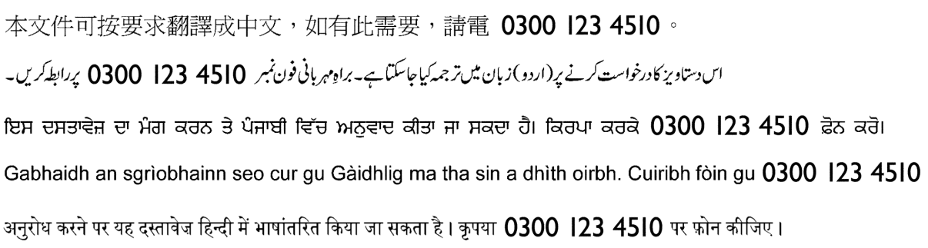**Kirkintilloch G66 1TJ Tel: 0300 123 4510**