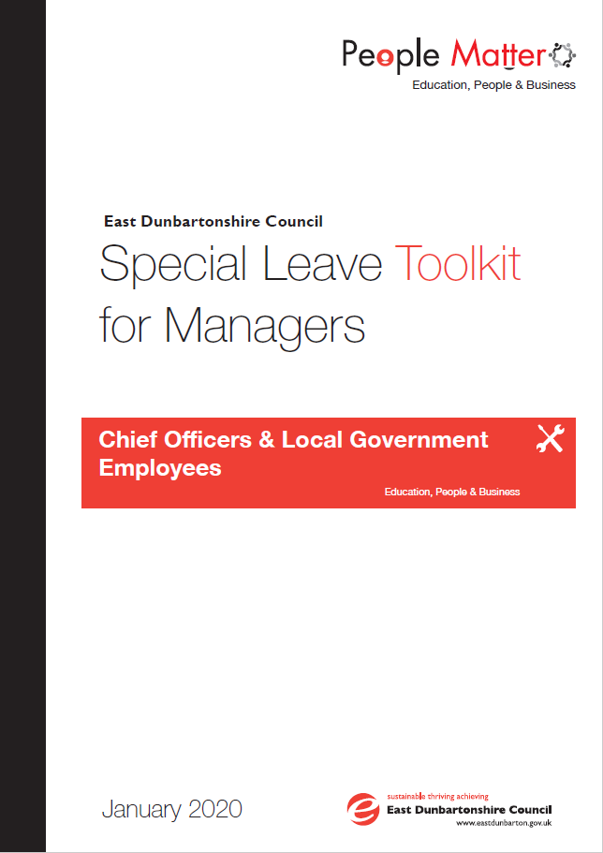

**Contents**

1.0 Purpose 3

2.0 Scope 3

3.0 Underpinning Principles 3

4.0 References 3

5.0 Process 4

6.0 Summary of Special Leave 4

7.0 Jury & Witness Service 9

8.0 Special Leave Application & Flow Chart 10

9.0 Special Leave Application Form 11

10.0 How to Log Special Leave on Itrent 11

11.0 Contact Details HR Case Advisor 13

**1.0 PURPOSE**

The toolkit is designed to assist managers in implementing the Council’s Special Leave Policy consistently and effectively.

**2.0 SCOPE**

The Special Leave Policy applies to Local Government Employees, Craft Employees and Chief Officers.

Teachers should refer to guidance manual 2/11 Special Leave for Teachers and Employees on Scottish Negotiating Committee (SNCT) Conditions of Service.

The regulations on special leave for employees of the Council are based on the principle that employees should not make personal arrangements which conflict with their contractual duties. Wherever possible, careful foresight should be exercised and requests for special leave submitted well in advance.

**3.0 UNDERPINNING PRINCIPLES**

The approach to special leave within the Council will be through the following principles:

* Confidentiality
* Objective Approach
* Sensitivity to the feelings of all employees involved
* Openness and honesty
* Effective information gathering
* Following the established procedures

**4.0 REFERENCES**

The Special Leave Policy & Toolkit is linked to a number of other policies as follows:

* Worklife Balance Policy
* Wellbeing at Work Policy and Toolkit
* Career Break Scheme
* Principles of Change
* Discipline at Work Policy and Toolkit
* Reserve Forces Toolkit

If it is believed that the special leave scheme is being abused the Disciplinary Procedures may be invoked.

**5.0 PROCESS**

The line manager should receive the employee’s special leave application form giving as much notice as possible. If the manager is unsure of the entitlement of special leave they should contact their HR Case Advisor for support. Contact details are as follows:

The manager must return the signed form to the employee. If the leave is unpaid the manager should inform the employee that this could constitute to a break in service and affect superannuation payments and pension.

If the application is approved the manager must log the special leave (both paid and unpaid) on iTrent.

**6.0 SUMMARY OF SPECIAL LEAVE**

|  |  |  |
| --- | --- | --- |
| **Circumstances** | **Leave Entitlement** | **Page in Policy** |
| **Balancing Work and Family Life & Domestic** | | |
| Family Domestic Emergencies | Employees who find it essential to be absent from duty due to a family emergency, leave with pay for up to a maximum of 1 day will normally be granted although this is at manager’s discretion. To receive payment employees must be able to demonstrate and/or provide clear explanation of the nature of the emergency | 5 |
| Emergency hospitalisation of family member & employee advised to stay at the hospital | Leave with pay for up to 5 days normally granted. | 6 |
| Care for family member | Leave without pay subject to monthly review may be granted. Employees on long term absence may consider Career Break Scheme. | 6 |
| Domestic emergency e.g. floods, fire, burglary | Reasonable leave with pay normally granted. | 6 |
| Domestic violence | Leave with pay for up to 5 days normally granted. Managers have the discretion to extend to 10 days. This can be taken in blocks or individual days (visit domestic abuse policy for more information) | 6 |
| Non-emergency/routine medical treatment e.g. optician, dentist, GP | Should be made out with normal working hours. If this is not possible, appointments should be made for the beginning or the end of the employee’s working day. In the event an employee is finding it difficult to gain an appointment within these times this should be discussed with their Manager with a view to reaching an alternative agreement which may include making up lost working time at a later stage or the use of annual leave. | 6 |
| Hospital appointments (medical examinations/interventions) | Reasonable time off with pay will be granted on display of a hospital appointment card or letter where available | 6 |
| Physiotherapy | Necessary paid time off if referred by GP or GP supports the treatment. Appointments should be made at beginning or end of the day to minimise disruption | 6 |
| Plastic Surgery | Special Leave not granted for elective surgery. Will be treated in accordance with the Wellbeing at Work Policy | 7 |
| Ante-natal Care | Time off with pay to attend clinics or appointments at the advice of a doctor/midwife/health visitor | 7 |
| Nursing Mother | Time off with pay during work (up to 60 minutes per day) for breastfeeding/expressing | 7 |
| Fertility Treatment | Time off with pay for appointments | 7 |
| Disabled Family Members | Time off with pay (max of 5 days per year) to take them to hospital appointments – time off subject to employee using annual leave for 50% of leave required | 7 |
| Bereavement | An employee will be given reasonable time off as necessary with pay, up to a maximum of 5 working days, including the day of the funeral in cases where the funeral is of a family member. Other relationships may be taken into account if the employee is required to make funeral arrangement or is required to travel overseas. Any leave granted beyond 5 days is without pay. Managers may, taking the circumstances into account, grant paid time off to allow employees to conduct business in preparation for the ceremony. This leave should not be taken in addition to the above. | 7 |
| All other bereavement cases | Paid time off to attend the ceremony | 7 |
| **National, Public and Community Service** | | |
| Reserve Forces | Up to 15 days leave with pay subject to the deduction of service pay received for the period of leave | 8 |
| Emergency Services | An employee is a retained employee in any of the emergency services employees should not be on-call during their working hours with East Dunbartonshire Council.  Paid time off will be given in circumstances where there is no risk to the business continuity and client base should the services of retained employees be required where a national emergency or critical incident be declared and the emergency services request further resources from their retained employee base. | 9 |
| Jury & Witness Service | Leave with pay to serve on jury. Leave with pay in cases of professional witness. Leave without pay where called as witness by person other than the Council. Leave with pay for attending tribunal involving the Council. Unpaid leave for those taking claims against the council. | 9 |
| Public Duties | Leave without pay for attendance at community council, health council, benefits agency appeals tribunal, college board of management, board of visitors for Prisons and Young Offenders Institution.  Leave with pay to attend meetings as members of school boards. Up to 10 days leave with pay for duties with Children’s panel or Justice of the Peace | 10 |
| International Sporting/Cultural Events | Representing country at international events – up to 10 working days paid leave (in any leave year) with evidence  Additional 10 working days paid leave for special events e.g. Commonwealth games, Olympics, European Championships  Leave without pay will be given for National Championships and Unofficial Sports. | 10 |
| Youth Organisation Holiday Camps etc. | Leave without pay | 10 |
| Election Duties | Paid leave to undertake official duties such as Presiding Officer, Polling Clerk & Enumerator at elections (provided exigencies of service being met and prior authorisation) | 10 |
| Election Candidates & Agents | Leave without pay not exceeding 4 weeks for employees who are candidates or election agents for the Scottish, Westminster or European Parliaments or local elections | 10 |
| Councillor Duties | Employees undertaking duties as a councillor with another local authority will be allowed reasonable time off (208 hours are paid) | 11 |
| Voluntary Service | Leave without pay to undertake duties of an honorary, charitable, philanthropic and civic character (will not exceed 5 days in any 1 year) | 11 |
| Voluntary Service Overseas | Leave without pay for up to 2 years provided the employee has 1 year’s continuous service | 11 |
| **Miscellaneous Situations Regarding Annual Leave and Public Holidays, Study & Interviews** | | |
| Interviews | Time off with pay for interviews with local government and subject to production of the interview letter. Employee who is in a redundancy/redeployment situation paid time off for interviews | 11 |
| Study Leave | Leave with pay for one day for final revision to formal examination, leave with pay granted for employees with approved sponsorship and no leave granted for resitting examinations | 11 |
| Third Party Claims | Annual leave and public holidays will not accrue during special leave related to a third party claim | 12 |
| Severe Weather/Adverse Conditions | Generally unpaid leave of absence if an employee is unable to report to work at council offices. Individual cases will be considered on their own merit and severity of the weather conditions | 12 |
| Visiting Relatives Overseas | Annual leave must be used. In exceptional circumstances leave without pay may be granted | 12 |
| Religious Festivals or Holidays | Employees who celebrate festivals other than those allocated by the council each year will be entitled to a maximum of 3 separate days leave without pay per year. This includes 1 day for ordination of a near relative | 12 |

**7.0 JURY & WITNESS SERVICE**

Upon receipt of a citation and after having reported the fact to their line manager, an employee should present the document to the Payroll department whereupon the individual’s current daily pay will be entered in the loss of earnings section and certified as correct by an official stamp.

Having attended Court, the court staff will calculate the loss of earnings/other expenses as appropriate to be paid and will record these on the citation. On payment of the claim the signature of the claimant will be required and the citation will be retained by the court. The employee should ask the court staff for a copy of the recited claim and after recording their employee number thereon should submit the copy claim to the Payroll department so that the amount received for the loss of earnings may be deducted from the next available salary/payment.

Any other expenses received such as travelling and subsistence payments should be retained by the individual.

For employees who receive unpaid leave to attend court any loss of earnings should be claimed from the person citing them.

**8.0 SPECIAL LEAVE APPLICATION & FLOWCHART**

Employee submits special leave application to manager

Manager reviews application in line with the Special Leave Policy/Toolkit

(HR Case Advisor for advice if required)

Unpaid leave approved

Special Leave application denied

Paid leave approved

**Inform employee:**

Signed and completed application sent to HR Service Support

**Inform employee**

Note: unpaid leave may constitute a break in service and affect superannuation payments & pension

All Special leave should be logged on iTrent

Signed and completed application should be submitted Employee Services

All Special leave should be logged on iTrent

Application denied and explained to employee

Signed and completed application should be submitted to Employee Services

**9.0 SPECIAL LEAVE APPLICATION FORM**

This following form is also available on the hub at:



**10.0 HOW TO LOG SPECIAL LEAVE ON ITRENT**

Special Leave should be logged under Absence Details - New Absence Details - Permissable Absence

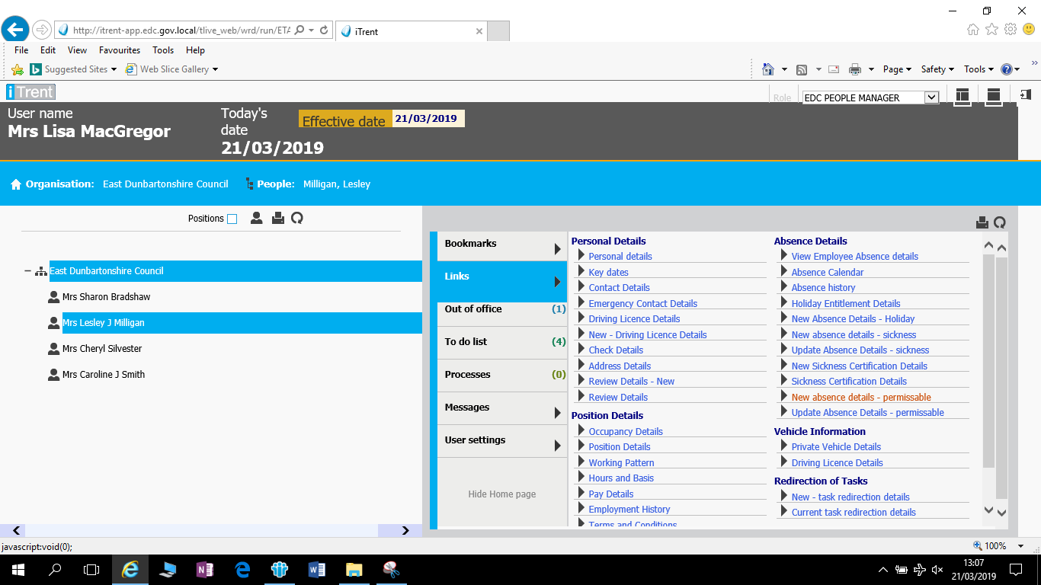

Details of the Special Leave can then be logged in the screens below with the drop down menu’s providing a list of options for recording

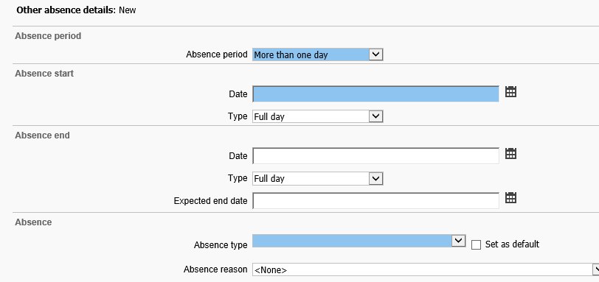

Once completed your screen will show details as per the example below which should then be saved. 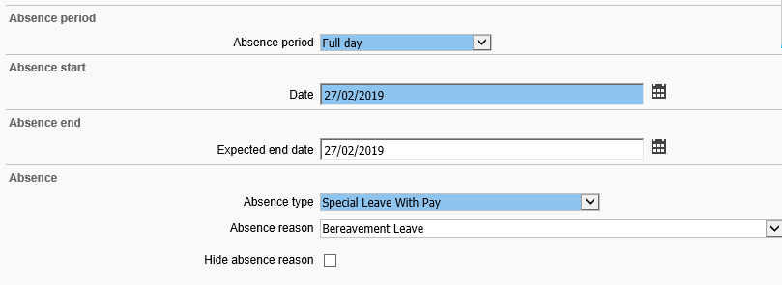

If an expected end date has been put in or you are required to update the Special Leave details this can be performed through selecting the special leave occurrence that has been logged and selecting Update Absence Details – Permissable as per the first screen.

**11.0 CONTACT DETAILS HR CASE ADVISOR**

HR Case Advisor contact details can also be found on the hub at:

[Workforce Strategy Contact List](http://thehub.eastdunbarton.gov.uk/sites/default/files/documents/council/plans-policies-and-strategies/workforce_strategy_contact_list.pdf)

**Other Formats & Translations**

This document can be provided in large print, Braille or on audio cassette and can be translated into other community languages. Please contact the Council’s Corporate Communications Team at:

East Dunbartonshire Council, 12 Strathkelvin Place, Southbank

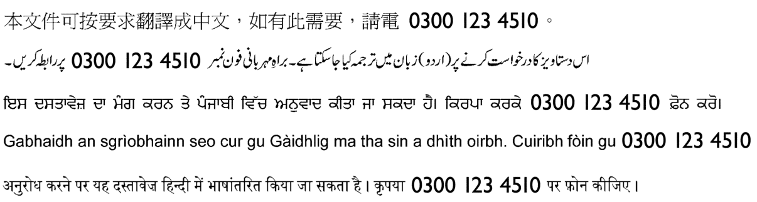**Kirkintilloch G66 1TJ Tel: 0300 123 4510**